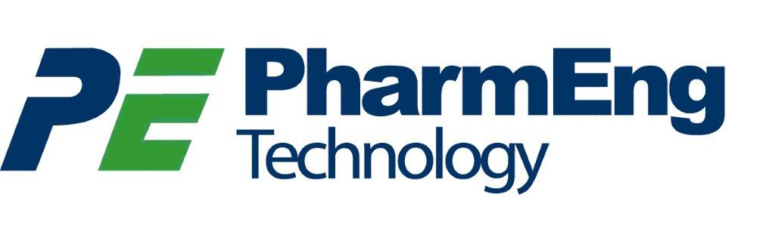

**Bryan Dumpit, B.Sc.**

Mr. Dumpit is a Bachelor of Science Graduate in Biotechnology with a graduate certificate in Quality Assurance. He has knowledge in quality assurance processes, validation, manufacturing, and laboratory testing with experience in quality systems, including authoring documents and deviations. His experience in Thermal Validation involves accurate documentation, analysis and summary of raw data in qualification protocols and reports. He has excellent analytical, organization and communication skills. He is very meticulous and pays special attention to detail. He is also proficient in MSOffice Suite (Word, PowerPoint, Excel, and Outlook).

**AREAS OF EXPERTISE**

* Thermal Validation – Moist Heat Sterilization
* Raw Data Analysis and Compilation
* Good Documentation Practices (GDP)
* Good Manufacturing Practices (GMP)
* Technical Writing (Protocols and Reports)
* Statistical Process Control
* Design of Experiments

**EDUCATION**

Quality Assurance – Manufacturing and Management – Graduate Certificate (Co-op), Sheridan College, Brampton, ON

Honours Bachelor of Science in Biotechnology, University of Toronto Mississauga, Mississauga, ON

**EXPERIENCE**

**Sanofi Pasteur, Toronto, ON (2018-2021)**

Thermal Validation Consultant

**Skelton Truck Lines Ltd, Sharon, ON (2018)**

Thermal Validation Consultant

**Sanofi Pasteur, Toronto, ON (2017-2018)**

Thermal Validation Co-op Student

## Career Details

**Sanofi Pasteur, Toronto, ON (2018-2021):**

* Coordinated project resources
* Executed thermal validation studies on autoclaves and SIP systems
* Authored technical documents: procedures, reports, and protocols
* Investigated non-conformances
* Ensured data accuracy and integrity as per GDP

**Skelton Truck Lines Ltd, Sharon, ON (2018):**

* Executed thermal mapping studies on refrigerated trailers
* Performed analyses of thermal mapping data
* Maintained documentation accuracy

**Sanofi Pasteur, Toronto, ON (2017-2018):**

* Assisted in IQ/OQ of thermally controlled equipment (e.g. Refrigerators, Incubators, Freezers)
* Supported PQ of sterilizing autoclave
* Analyzed and compiled qualification raw data
* Drafted qualification protocols, reports and validation master plan
* Participated in non-conformance investigation
* Collaborated with a process improvement project team
* Facilitated project team meetings